Domain Name Server (DNS)

Instructions

You will set up two DNS servers on R1 and R2 that will host a primary and secondary zone, respectively.

R1 will be configured as the primary DNS server which will host the primary zone “cn.” This zone will contain R1, R2, and Kali. R2 will host the secondary zone, “second.cn.”, that will contain R2, R3, R4 and Ubuntu.

*Please note that the zone names should be named with a period (.) at the end.

Your goal is to configure a DNS server using BIND9 such that each machine can ping another by name. (e.g. ping Kali).

**Part 1: Setup DNS Resolution**

Prior to configuring our DNS servers, you need to setup our DNS resolution.

For each machine in Area 0, go to /etc/resolv.conf and replace any existing configuration directives with the following:

nameserver<eth1 interface address of R1>

domain <name of primary zone>

search <name of primary zone>

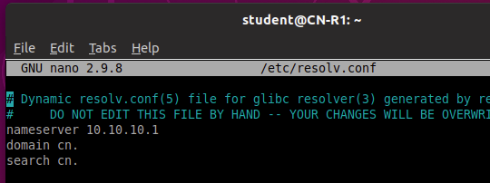

**Part 2:**

On R1, edit /etc/bind/named.conf.local to include forward and reverse DNS zone names to BIND9.

Using the below template, name the primary zone, “cn.” and the forward zone file as “db.cn”:

zone "<primary zone>" {

type master;

file "/etc/bind/db.example";

};

Create another entry for the reverse zone, but this time you will name it according to the first three octets of our primary zone server; that is, “10.10.10.” and “db.10.10.10” for the reverse zone name and the reverse zone file, respectively.

Next, you will need to create and edit the forward and reverse zone files. The below command will allow you to copy an existing template:

sudo cp /etc/bind/db.local /etc/bind/db.cn

Edit this file by adding A records for R1, R2, and Kali.

You will do the same steps with the Reverse zone file which allows the DNS to resolve an address to a name. The above steps are roughly equivalent, except that you should create pointers for each A record that you configured in the forward zone file.

A pointer should be formatted like so:

10.X.X.X IN PTR <machine>.cn.

Once you’ve configured the forward and reverse zone files, restart the DNS service on R1.

sudo systemctl restart bind9.service

At this stage, you should be able to ping each machine by name from any machine in Area 0.

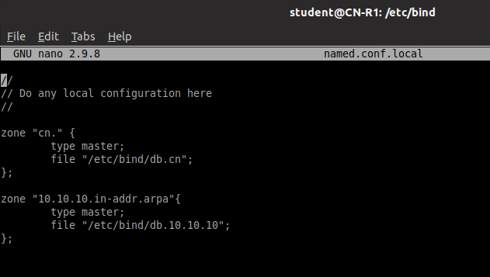

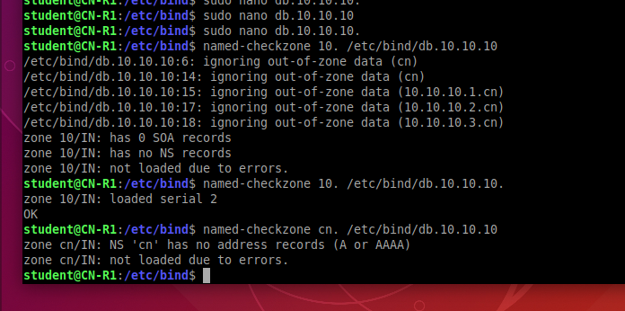

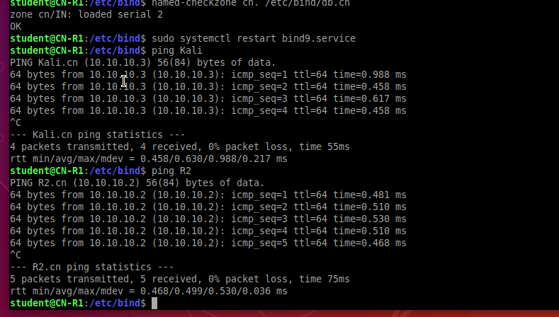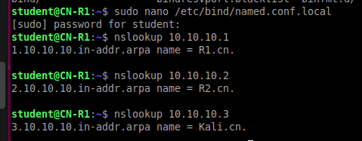

**Part 3:**

You will follow roughly the same steps in Parts 1 and 2 to configure the forward and reverse zone files for the secondary zone on R2. You will name the secondary zone second.cn. and use the IP interface configurations for R3, R4 and Ubuntu in the forward zone file.

Remember that your reverse zone file must be named according to the first 3 octets of your zone name.

You should be able to ping R2, R3, R4, and Ubuntu from any machine in Area 1. To link the subzone (second.cn.) to the main zone (cn.) add a NS record to the cn. zone file (/etc/bind/db.cn) which points to the address (R2) which hosts the second.cn. zone file.

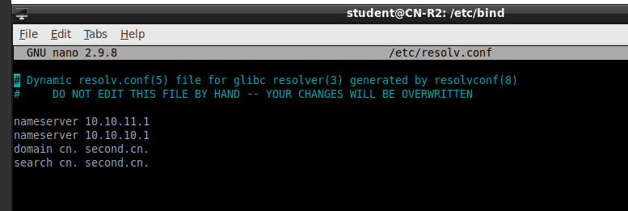

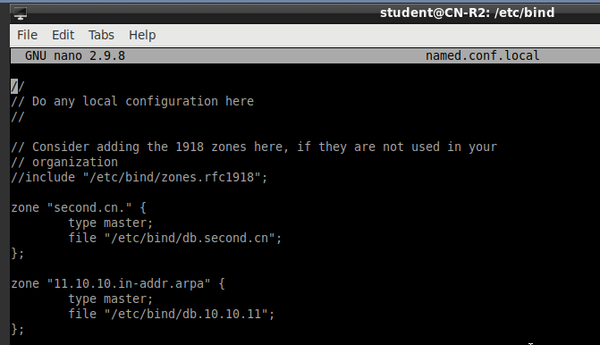

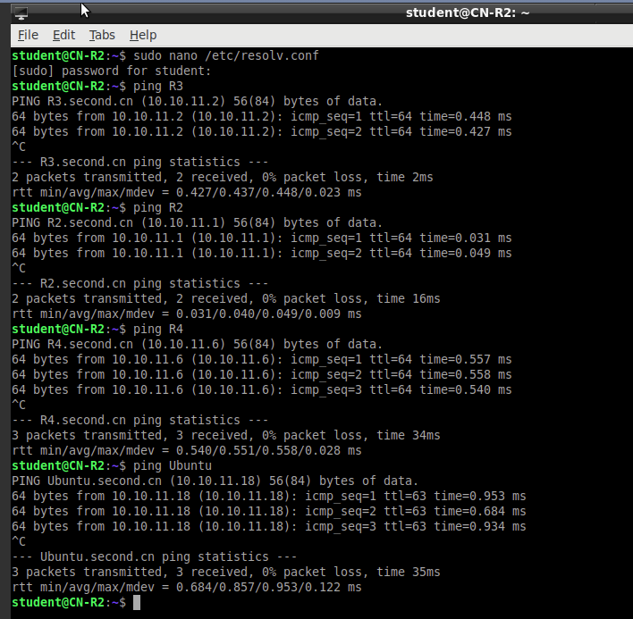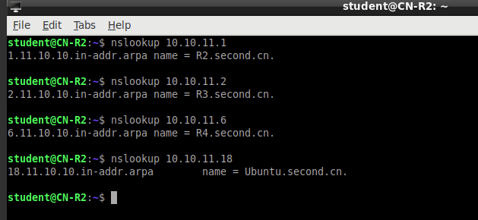

Submissions

[20 points] Forward and Reverse zone files for primary DNS server.

Primary

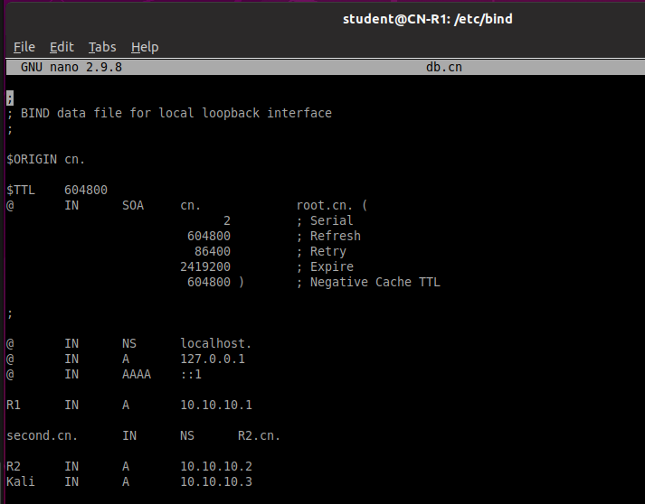

Reverse DNS zone

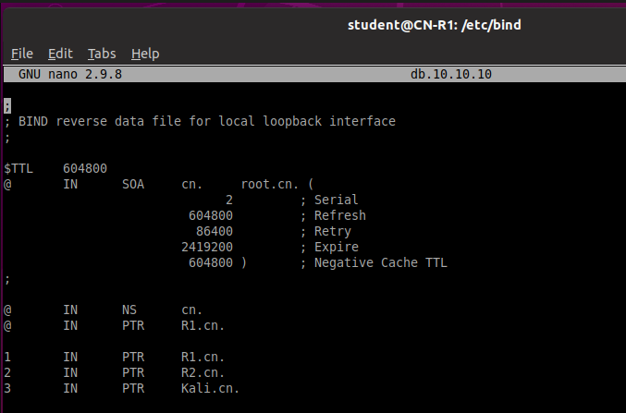

[30 points] Forward and Reverse zone files for secondary DNS server

Primary zone file

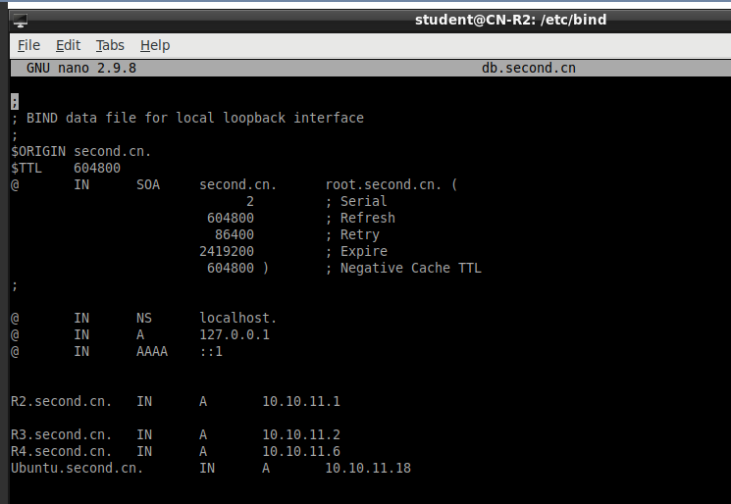

Reverse zone file

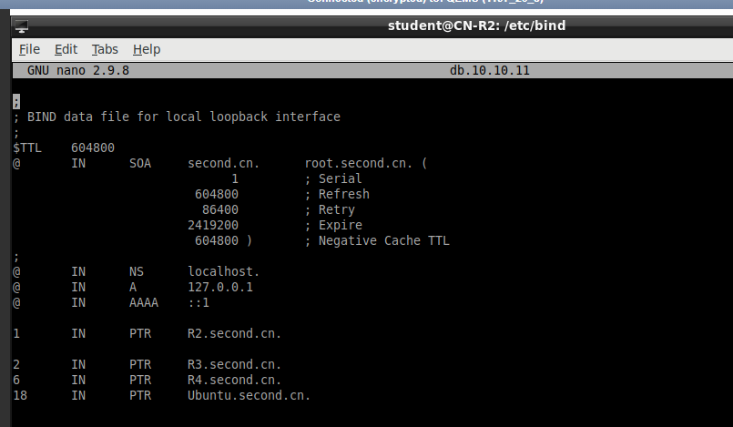

[20 points] Screenshots of R1 pinging R2 and Kali

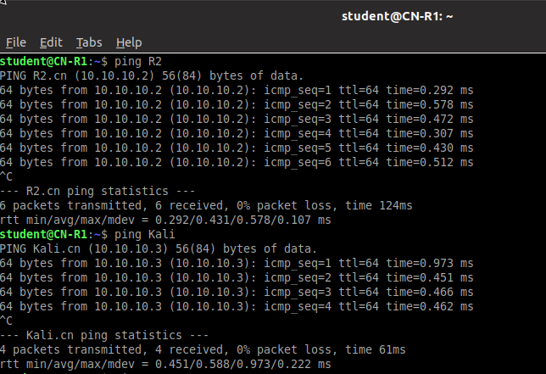

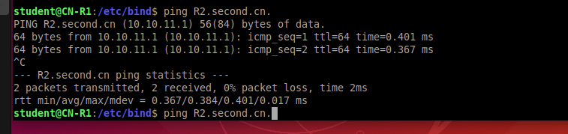

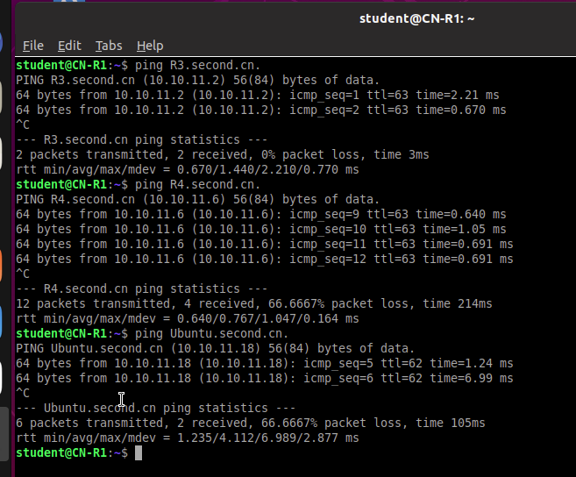

[30 points] Screenshots of R2 pinging R3, R4, and Ubuntu

